LOGISTICS DATA ANALYST INTERNSHIP

Week 1: Strategic Planning and Data Exploration in Logistics

Project Title
Logistics Delivery Performance Analysis and Late Delivery Prediction Using Python
Submitted by: Priya Rao
Internship: Logistics Data Analyst Intern
Organization: NSDC Yuva Shakti
Duration: 30 July 2026 – 27 August 2026

1. Introduction
Logistics plays an important role in e-commerce because efficient delivery directly affects customer satisfaction, operational efficiency and business performance. Delays in delivery can increase operational costs, reduce customer satisfaction and negatively affect the overall supply chain.
This project focuses on analyzing e-commerce order and delivery data to understand delivery performance and identify patterns associated with late deliveries. Python and data science techniques are proposed to support logistics decision-making.

2. Project Background
The project considers an e-commerce logistics scenario in which a company handles a large number of customer orders. The company wants to monitor delivery performance and understand why some orders are delivered later than their estimated delivery dates.
The analysis uses the Brazilian E-Commerce Public Dataset by Olist, which contains information related to orders, customers, sellers, products, payments and deliveries.
The main focus of this Week 1 analysis is the order dataset, particularly purchase date, actual delivery date and estimated delivery date.

3. Problem Statement
The logistics company needs a data-driven approach to monitor delivery performance, identify delayed orders and understand the factors that may contribute to delivery delays.
The project therefore aims to analyze historical order data, calculate important logistics KPIs and establish a roadmap for predictive analysis of late deliveries.

4. Project Objectives
The major objectives of the project are:
- To analyze historical e-commerce delivery data using Python.
- To calculate important logistics performance indicators.
- To measure late and on-time delivery performance.
- To calculate average delivery time.
- To identify patterns that may contribute to delivery delays.
- To propose predictive modelling techniques for future late-delivery prediction.
- To provide data-driven insights that can support logistics decision-making.

5. Dataset Description
The project uses the Brazilian E-Commerce Public Dataset by Olist. The dataset contains approximately 100,000 orders and multiple related datasets covering orders, customers, sellers, products, payments, reviews and order items.
For the initial analysis, the olist_orders_dataset.csv file was used. It contains order status and important timestamps including order purchase time, customer delivery date and estimated delivery date.
These fields allow delivery duration and late-delivery status to be calculated.

6. Key Performance Indicators (KPIs)
The following KPIs were selected for the project:
KPI | Description
Total Orders | Total number of orders analyzed
Late Delivery Rate | Percentage of delivered orders delivered after the estimated date
Average Delivery Time | Average number of days between purchase and customer delivery
On-Time Orders | Number of orders delivered on or before the estimated delivery date
The initial Python analysis produced the following results:
- Total Orders: 99,441
- Late Orders: 7,827
- On-Time Orders: 91,614
- Late Delivery Rate: 7.87%
- Average Delivery Time: 12.09 days
These results provide an initial view of the delivery performance of the analyzed dataset.

7. Data Analysis Approach
The proposed analysis follows an end-to-end data science workflow.

7.1 Data Collection
The publicly available Olist e-commerce dataset was selected as the source of historical logistics data.

7.2 Data Cleaning
The data is checked for missing values, incorrect data types and inconsistent records. Date columns are converted into appropriate datetime formats so that delivery duration can be calculated.

7.3 Exploratory Data Analysis
Exploratory analysis can be used to understand order volume, delivery duration and differences between late and on-time orders.
Charts and summary statistics can help identify patterns and unusual observations.

7.4 KPI Calculation
Logistics KPIs such as late delivery rate, average delivery time and on-time orders are calculated using Python.

7.5 Feature Engineering
Additional variables can be created from the available data. Examples include delivery duration, late-delivery indicator and other relevant order or geographical features.

8. Application of Data Science Techniques

Classification
Classification can be used to predict whether an order will be delivered late or on time. The target variable can be represented as:
0 = On Time
1 = Late
A model such as Random Forest Classifier can be considered for this task.

Regression
Regression can be used to predict a numerical outcome such as the expected number of delivery days.

Clustering
Clustering can be used to group sellers, customers or geographical areas based on delivery performance and logistics characteristics.

Optimization
Optimization techniques can potentially be applied to improve resource allocation and delivery routes. This can help logistics managers make better operational decisions.

9. Strategic Roadmap
The proposed end-to-end workflow is:
Data Collection → Data Cleaning → Data Transformation → Exploratory Data Analysis → KPI Calculation → Feature Engineering → Predictive Modelling → Model Evaluation → Business Recommendations
The first stage of this roadmap has been implemented using Python by loading the order dataset, converting date columns, calculating delivery duration and identifying late deliveries.

10. Python Code Illustration
The following Python code was used to load the order dataset:
import pandas as pd

orders = pd.read_csv("/content/olist_orders_dataset.csv")

orders.head()
Date columns were converted into datetime format:
date_columns = [
"order_purchase_timestamp",
"order_delivered_customer_date",
"order_estimated_delivery_date"
]

for column in date_columns:
orders[column] = pd.to_datetime(orders[column])
Delivery duration was calculated as follows:
orders["delivery_days"] = (
orders["order_delivered_customer_date"]
- orders["order_purchase_timestamp"]
).dt.days
Late deliveries were identified using:
orders["is_late"] = (
orders["order_delivered_customer_date"]
> orders["order_estimated_delivery_date"]
).astype(int)
The late-delivery rate was then calculated:
late_delivery_rate = orders["is_late"].mean() * 100

print("Late Delivery Rate:",
round(late_delivery_rate, 2), "%")
The average delivery time was calculated using:
average_delivery_time = orders["delivery_days"].mean()

print("Average Delivery Time:",
round(average_delivery_time, 2),
"days")

11. Visualization
Figure1. On Time vs Late Deliveries
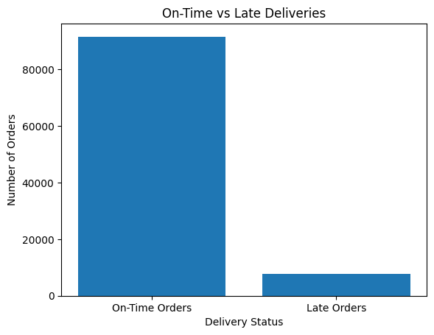
A bar chart was created using Python to compare on-time and late orders.
The analysis identified:
- 91,614 on-time orders
- 7,827 late orders
The visualization provides a simple comparison of delivery performance and can be included in the final analysis dashboard or report.

12. Expected Outcomes
The proposed analysis is expected to provide a clear understanding of delivery performance and help identify areas where logistics operations can be improved.
Predictive modelling can further help identify orders that have a higher probability of being delayed. Such information could allow logistics managers to take preventive actions, improve resource allocation and monitor high-risk deliveries.

13. Business Impact
The analysis can support logistics decision-making by providing measurable KPIs and data-driven insights.
Monitoring delivery performance can help the organization identify operational problems, improve customer service and reduce the impact of delivery delays.

14. Conclusion
This Week 1 project establishes a strategic framework for logistics data analysis using Python. The initial analysis of the Olist order dataset successfully calculated important delivery metrics, including total orders, late orders, on-time orders, late delivery rate and average delivery time.
The proposed roadmap can be extended with exploratory analysis, feature engineering and machine learning models for late-delivery prediction. The overall approach demonstrates how data science can support logistics performance monitoring and better operational decision-making.

15. References
- Olist Brazilian E-Commerce Public Dataset, Kaggle.
- Python Pandas documentation.
- Scikit-learn documentation.

